

Predicting Credit Card Payments
Deautaun Ross, Jasmine Castañeda, and Marci Morrell

Almost everyone uses a credit card in today’s world. Not everyone, however, pays off their credit card debts in a timely manner–or at all. Because of this, we wanted to build models that would potentially give credit card companies the ability to predict whether or not a card holder will pay off their debt in a timely manner, and the percent of payments that they will likely miss.
The data set we used to build and train our model comes from Kaggle (https://www.kaggle.com/datasets/mlg-ulb/creditcardfraud). The original data set contained over 777,000 rows, and included information such as customer ID, customer salary, customer age, card status, etc. For data cleaning, we renamed all of the columns to be more useful, dropped the occupation column because of the amount of missing rows, label encoded all of the objects, and only used clients who had been card holders for 6 months or greater. For simplicity and ease of analysis, we created summary statistics for each individual card holder, such as the percentage of payments they have missed, amount of times they have appeared in the data set, and their mode card status.
Mode card status has 7 separate values which correspond to how late a card holder’s payment tends to be. Those 7 values are 0 (which represents a payment late by less than a month), 1 (late by 1-2 months), 2 (late by 2-3 months), 3 (late by 3-4 months), 4 (late by 4-5 months), 5 (late by more than 5 months), C (meaning the payment has been cleared), and X (meaning that no loan had been taken out for that month.
Since the goal of our project was to build models which would predict the percentage of payments a customer has missed and their mode card status, we wanted to do some general analysis on these values in the data. The median percentage of payments that a customer will miss is 45%, and the distribution of these missed payments is shown in Figure 1.
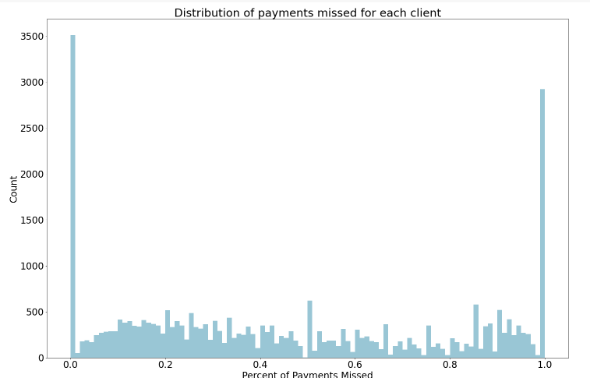
Figure 1
As can be seen in Figure 1, the majority of card holders in the data set either missed all of their payments or none at all, with a small percentage of card holders falling in between these categories. Accordingly, the most common mode card status for a card holder was C, meaning that their payment was cleared in a timely manner. A distribution plot of the mode card status is shown in Figure 2.
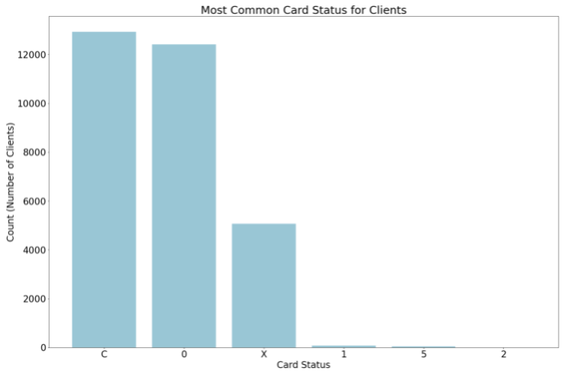
Figure 2
With this basic analysis of our target columns, we wanted to begin the process of constructing our model. We began by showing the feature importance of the columns in our data set. This is shown in Figure 3.
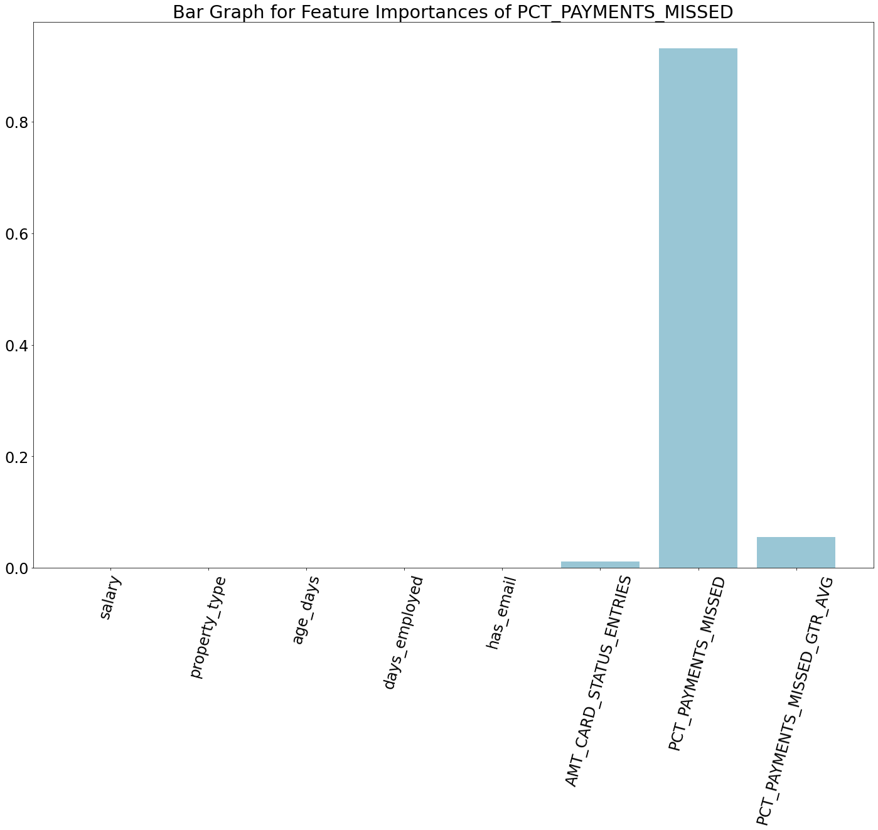
Figure 3
Using feature importance, we were able to determine that the best columns to input into our model would be the card holder’s salary, type of property they own/rent, their age, the time they have been employed, whether or not they have an email, length of card holding, mode card status (for predicting percentage of payment missed), and whether the percent of payments they missed was above the median percentage of payments missed by all card holders (used for predicting the mode card status).
We constructed two models: a gradient boosting regression model for predicting the percentage of payments missed, and a gradient boosting classification model for predicting the mode card status of the card holder. For both models, we used GridSearchCV for hyperparameter tuning. The hyperparameters tuned were min_samples_split, min_samples_leaf, max_depth, loss, learning_rate, n_estimators, criterion, tol, validation_fraction, and n_iter_no_change.
A graph showing the accuracy of the regression model is shown in Figure 4.
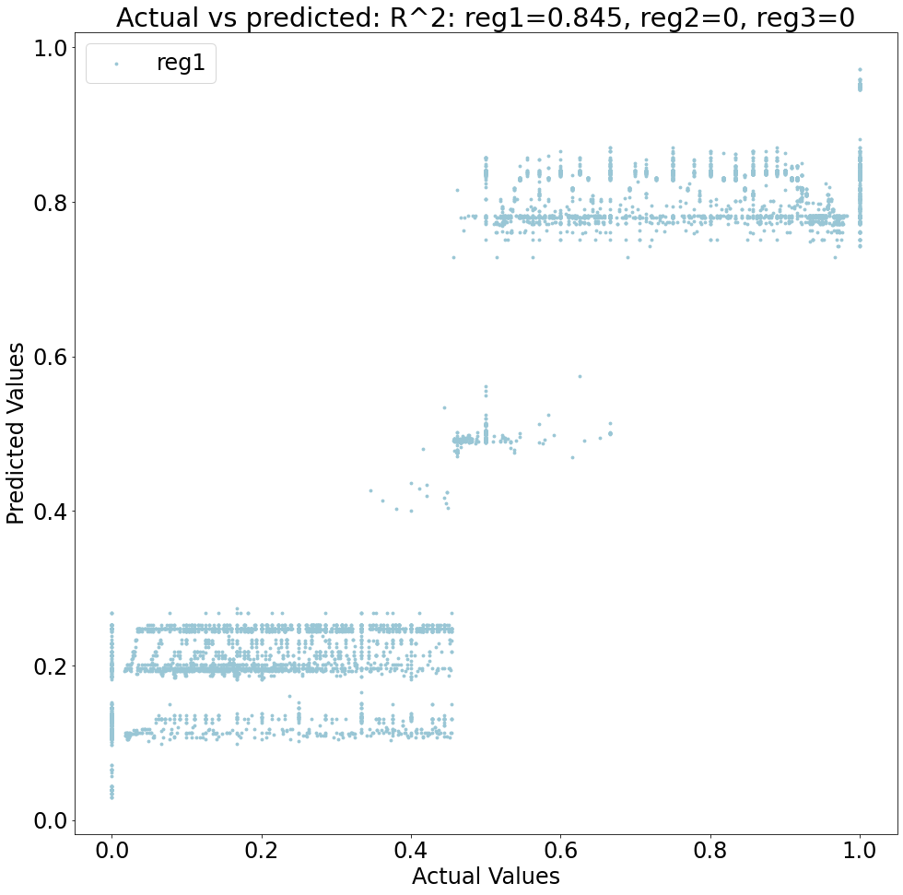
Figure 4
While the model has a high accuracy, it can be seen that it is very limited in the amount of values it predicts for the percent of payments missed. Additionally, it struggles with predicting values for people who have missed between 30% and 70% of their payments. We will discuss ways we tried to fix these issues in conjunction with the limitations of the second model.
A confusion matrix showing the predictions of the second model can be seen in Figure 5.
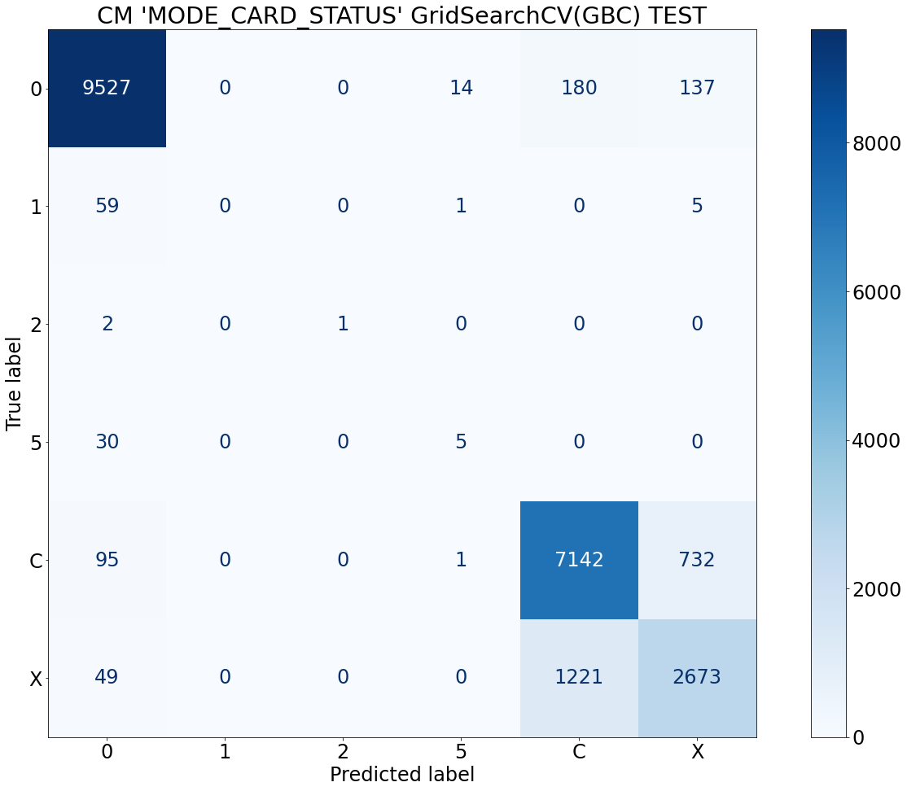
Figure 5
As can be seen, the model never predicted certain values of mode card status, hence the missing numbers in the matrix. However, the model did predict the mode card status of a card holder with up to 88% accuracy.
As previously seen, our regression model had difficulty predicting percent of payments missed between 30% and 70%. We noted that the majority of card holders missed either 0% or 100% of payments, so we tried cutting off those values and building a model with only card holders missing between 30% and 70%. We encountered the same issues after this, and also when balancing the data. Furthermore, we tried building a logistic regression model and comparing the probability of their mode card status classification to the percent of payments missed. There was no significant correlation between these values. With the classification model, it is clear that there is a lack of entries in the data where a card holder’s mode card status is between 1 and 5.
In general, since the majority of card holders miss either 0% or 100% of payments, we conclude that it would be fruitful to conduct this analysis again with a more balanced, thorough data set. However, we were also able to conclude that salary,property type, age, days employed,whether someone has an email, length of card holding, and mode card status were the most important things to look at when analyzing card holders.

